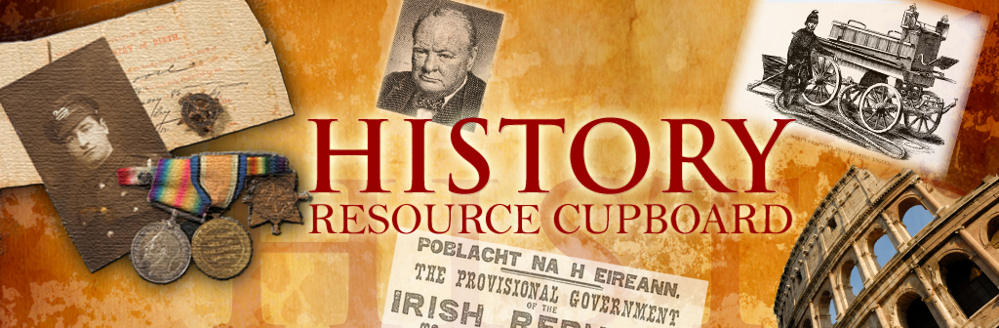

**Possible enquiry questions to structure learning around**

**Cause**

* Was one American General really so important in causing the USSR and USA to fall out?
* Who was the most to blame for the Berlin crisis?
* What made the Northern Earls Revolt?
* Why did so few people oppose the Nazis?
* How serious a challenge did Elizabeth I face from Mary Queen of Scots?
* Why were there such huge changes to medicine the 19th century?

**Consequence**

* What were the consequences of the Hungarian uprising?
* What were the most important effects of the Cuban Missile Crisis?

**Similarity / Difference**

* Was public health in the early modern period really that different to public health in the Middle Ages?
* Was there anything new about 20th century crime?
* Was Henry Metlemann a typical young German?

**Change / continuity / turning points**

* Was Cuba the closest the world came to nuclear war**?**
* How far did Helga Koller’s life change after 1933?
* When was the best time to go to prison 1750-1900?
* Did the 19th century see the biggest change in policing?
* How far did crime prevention change in the later Middle Ages?
* Why were there such huge changes to medicine the 19th century?
* Do changes in Public Health after 1900 simply tell the story of progress?
* IS the story of policing in the 20th century one of progress?
* Why were there such huge changes to medicine the 19th century?
* Did the 19th century see the biggest change in medicine?

**Significance**

* Who should survive a re-hang in the National Portrait Gallery: Drake or Raleigh?
* Which individual should go on the back of a fiver?
* How would you structure a documentary about threats to power in Germany in in 1923?
* How seriously did the Barons challenge John?
* What was the wobbliest domino in Asia 1945-55?
* How serious a challenge did Elizabeth I face from Mary Queen of Scots?
* How big a threat were the ‘new crimes’ in the Early Modern Period to the law-makers?
* Which was the greatest problem facing Elizabeth in 1558?
* What should a BBC web-page tell us about the problems facing Elizabeth in 1558?

**Sources**

* How good your German is: Can you produce a textbook caption for this cartoon from 1924?
* Why is it difficult to work out who won WW2?
* Can you really trust eye-witnesses to tell you the truth about X?

**Interpretations**

* How do historians disagree about X when they look at the same sources?
* How far does King John deserve his reputation?
* Was Elizabeth’s reign a golden age of culture?
* How accurately does the end of Robin Hood Prince of Thieves portray King John?
* How accurately does a 1930s film portray why England went to war with Spain?
* To what extent to historians disagree about the influence of the Gestapo?
* How far do you agree with a young German’s memoir about life in 1933?